
SRM Institute of Science and Technology
Mode of Exam
OFFLINE
College of Engineering and Technology
School of Computing
DEPARTMENT OF COMPUTING TECHNOLOGIES
SRM Nagar, Kattankulathur – 603203, Chengalpattu District, Tamilnadu
Academic Year: 2021-2022 (EVEN)
Test: CLAT-1 Date: 4-4-2022
Course Code & Title: 18CSC205J: Operating systems Duration: 1 Period
Year & Sem: II & IV Max. Marks: 25 Marks
Course Outcomes (CO): |  |  |  |  |  |  | At the end of this course, learners will be able to:
CO-1 : |  | Express the fundamental concepts in operating system
Program Outcomes (PO)
1 | 2 |  | 3 | 4 | 5 | 6 |  | 7 | 8 | 9 | 10 | 11 | 12 | PSO
Engineering Knowledge | Problem Analysis |  | Design & Development | Analysis, Design, Research | Modern Tool Usage | Society & Culture |  | Environment & Sustainability | Ethics | Individual & Team Work | Communication | Project Mgt. & Finance | Life Long Learning | PSO - 1 | PSO - 2 | PSO – 3
3 |  |  | 3 |  |  |  |  |  |  |  |  |  |  | 2

Part - A
(5 x 1 = 5 Marks)
Instructions: Answer all
Q. No | Question | Marks | BL | CO | PO | PI Code
1 | When the process issues an I/O request __________  A. It is placed in an I/O queue  B. It is placed in a waiting queue  C. It is placed in the ready queue  D. It is placed in the Job queue | 1 | 1 | 1 | 1 | 1.6.1
2 | Inter process communication can be done through __________.  A. Mails  B. Message  C. System calls  D. Traps | 1 | 1 | 1 | 1 | 1.6.1
3 | Increasing the RAM of a computer typically improves performance because:  A. Virtual memory increases  B. Larger RAMs are faster  C. Fewer page faults occur  D. Fewer segmentation faults occur | 1 | 1 | 1 | 1 | 1.6.1
4 | To access the services of operating system, the interface is provided by the ___________  A. System calls  B. API  C. Library  D. Assembly instructions | 1 | 1 | 1 | 1 | 1.6.1
5 | In UNIX, the return value for the fork system call is _____ for the child process and _____ for the parent process.  - A Negative integer, Zero  - Zero, A Negative integer  - Zero, A nonzero integer  - A nonzero integer, Zero | 1 | 1 | 1 | 1 | 1.6.1
Part – B
(5 x 4 = 20 Marks)
Instructions: Answer any 5
6 | With a neat sketch brief typical process implementation | 4 | 3 | 1 | 3 | 2.6.2
7 | Write short notes on process termination? | 4 | 3 | 1 | 1 | 1.7.1
8 | Explain about cooperating process? | 4 | 2 | 1 | 1 | 1.7.1
9 | Write short notes on critical section problem? | 4 | 3 | 1 | 1 | 1.7.1
10 | Compare threads versus process. | 4 | 4 | 1 | 2 | 2.6.4
11 | Summarize the various functions of process control block | 4 | 2 | 1 | 2 | 2.6.2

Course Outcome (CO) and Bloom’s level (BL) Coverage in Questions

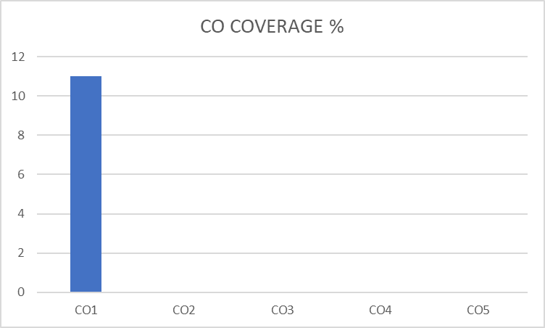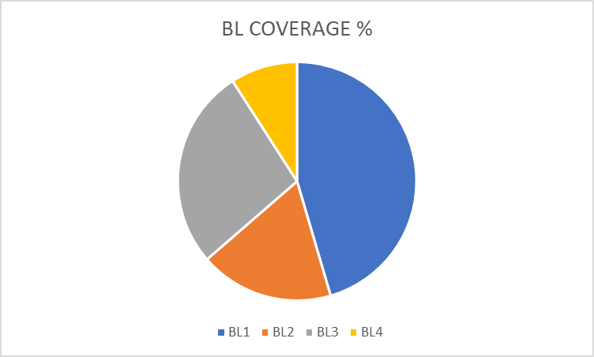

Approved by the Audit Professor/Course Coordinator

